University Student Academic Management System Using MySQL using MySQL

Table Schema
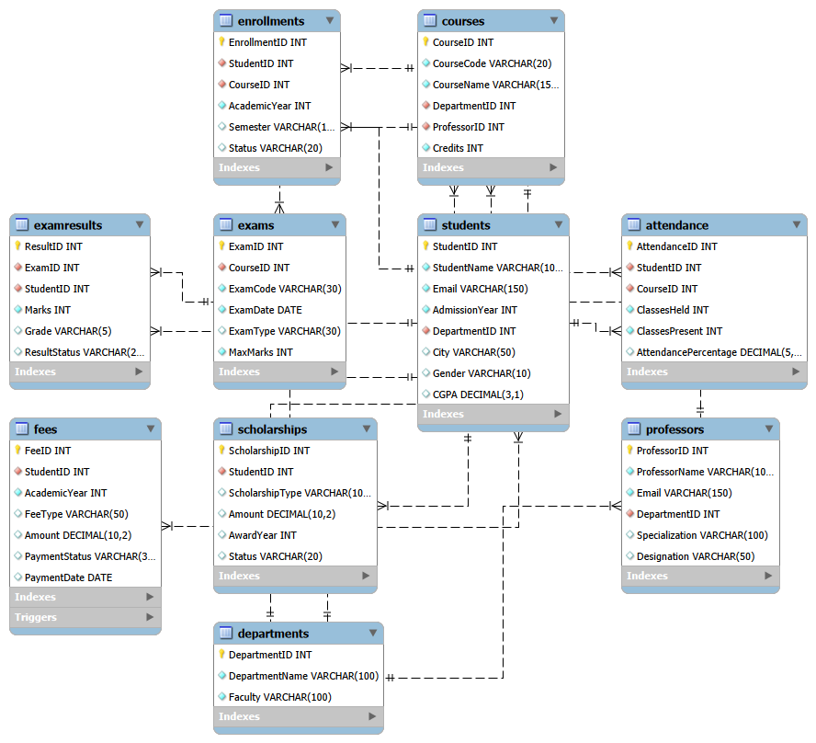
PROJECT OBJECTIVE :
The main objective of this project is to design and implement a University Student Academic Management System database using MySQL. The system efficiently manages university operations including student records, department details, professor information, courses, enrollments, examinations, exam results, attendance, scholarships, and fee records. The database minimizes redundancy, maintains data integrity using primary and foreign keys, establishes relationships between different entities, and enables efficient retrieval and analysis of academic information through SQL queries.
BASIC SQL QUESTIONS AND ANSWERS
================================

Q1. Display all records from the Departments table.

Answer:
SELECT *
FROM Departments;

Q2. Display StudentID, StudentName, City, and CGPA of all students.

Answer:
SELECT StudentID, StudentName, City, CGPA
FROM Students;

Q3. Display all female students.

Answer:
SELECT *
FROM Students
WHERE Gender = 'Female';

Q4. Find students whose CGPA is greater than 8.5.

Answer:
SELECT StudentID, StudentName, CGPA
FROM Students
WHERE CGPA > 8.5;

Q5. Find students who were admitted in 2024.

Answer:
SELECT StudentID, StudentName, AdmissionYear
FROM Students
WHERE AdmissionYear = 2024;

Q6. Display students who belong to Chennai.

Answer:
SELECT StudentID, StudentName, City
FROM Students
WHERE City = 'Chennai';

Q7. Display all students in ascending order of their names.

Answer:
SELECT StudentID, StudentName, City, CGPA
FROM Students
ORDER BY StudentName ASC;

Q8. Display the top 10 students based on CGPA.

Answer:
SELECT StudentID, StudentName, CGPA
FROM Students
ORDER BY CGPA DESC
LIMIT 10;

Q9. Display professors whose designation is Professor.

Answer:
SELECT ProfessorID, ProfessorName, Specialization, Designation
FROM Professors
WHERE Designation = 'Professor';

Q10. Display courses having 4 credits.

Answer:
SELECT CourseID, CourseCode, CourseName, Credits
FROM Courses
WHERE Credits = 4;

Q11. Find the total number of students.

Answer:
SELECT COUNT(*) AS TotalStudents
FROM Students;

Q12. Find the total number of professors.

Answer:
SELECT COUNT(*) AS TotalProfessors
FROM Professors;

Q13. Find the average CGPA of all students.

Answer:
SELECT ROUND(AVG(CGPA), 2) AS AverageCGPA
FROM Students;

Q14. Find the highest CGPA among students.

Answer:
SELECT MAX(CGPA) AS HighestCGPA
FROM Students;

Q15. Find the lowest CGPA among students.

Answer:
SELECT MIN(CGPA) AS LowestCGPA
FROM Students;

Q16. Find the total number of courses.

Answer:
SELECT COUNT(*) AS TotalCourses
FROM Courses;

Q17. Find the total scholarship amount given to students.

Answer:
SELECT SUM(Amount) AS TotalScholarshipAmount
FROM Scholarships;

Q18. Find the total fee amount recorded in the Fees table.

Answer:
SELECT SUM(Amount) AS TotalFeeAmount
FROM Fees;

Q19. Display all fee records where the payment status is Paid.

Answer:
SELECT *
FROM Fees
WHERE PaymentStatus = 'Paid';

Q20. Display all exam results where the result status is Pass.

Answer:
SELECT *
FROM ExamResults
WHERE ResultStatus = 'Pass';

INTERMEDIATE SQL QUESTIONS AND ANSWERS
======================================

Q21. Find the number of students in each department.

Answer:
SELECT DepartmentID, COUNT(*) AS TotalStudents
FROM Students
GROUP BY DepartmentID;

Q22. Find the average CGPA of students in each department.

Answer:
SELECT DepartmentID, ROUND(AVG(CGPA), 2) AS AverageCGPA
FROM Students
GROUP BY DepartmentID;

Q23. Display department name along with the number of students in each department.

Answer:
SELECT D.DepartmentName,
COUNT(S.StudentID) AS TotalStudents
FROM Departments D
LEFT JOIN Students S
ON D.DepartmentID = S.DepartmentID
GROUP BY D.DepartmentID, D.DepartmentName;

Q24. Display each department and the number of professors working in it.

Answer:
SELECT D.DepartmentName,
COUNT(P.ProfessorID) AS TotalProfessors
FROM Departments D
LEFT JOIN Professors P
ON D.DepartmentID = P.DepartmentID
GROUP BY D.DepartmentID, D.DepartmentName;

Q25. Display each department and the number of courses offered by it.

Answer:
SELECT D.DepartmentName,
COUNT(C.CourseID) AS TotalCourses
FROM Departments D
LEFT JOIN Courses C
ON D.DepartmentID = C.DepartmentID
GROUP BY D.DepartmentID, D.DepartmentName;

Q26. Display departments whose average CGPA is greater than 8.5.

Answer:
SELECT D.DepartmentName,
ROUND(AVG(S.CGPA), 2) AS AverageCGPA
FROM Departments D
JOIN Students S
ON D.DepartmentID = S.DepartmentID
GROUP BY D.DepartmentID, D.DepartmentName
HAVING AVG(S.CGPA) > 8.5;

Q27. Display each student's name along with their department name.

Answer:
SELECT S.StudentID,
S.StudentName,
D.DepartmentName
FROM Students S
JOIN Departments D
ON S.DepartmentID = D.DepartmentID;

Q28. Display professor name, specialization, and department name.

Answer:
SELECT P.ProfessorName,
P.Specialization,
D.DepartmentName
FROM Professors P
JOIN Departments D
ON P.DepartmentID = D.DepartmentID;

Q29. Display course name along with the professor teaching the course.

Answer:
SELECT C.CourseName,
P.ProfessorName
FROM Courses C
JOIN Professors P
ON C.ProfessorID = P.ProfessorID;

Q30. Display course name, course code, and department name.

Answer:
SELECT C.CourseCode,
C.CourseName,
D.DepartmentName
FROM Courses C
JOIN Departments D
ON C.DepartmentID = D.DepartmentID;

Q31. Display student name, course name, academic year, semester, and enrollment status.

Answer:
SELECT S.StudentName,
C.CourseName,
E.AcademicYear,
E.Semester,
E.Status
FROM Enrollments E
JOIN Students S
ON E.StudentID = S.StudentID
JOIN Courses C
ON E.CourseID = C.CourseID;

Q32. Display students along with their scholarship details.

Answer:
SELECT S.StudentName,
SC.ScholarshipType,
SC.Amount,
SC.AwardYear,
SC.Status
FROM Scholarships SC
JOIN Students S
ON SC.StudentID = S.StudentID;

Q33. Display student name, fee type, amount, and payment status.

Answer:
SELECT S.StudentName,
F.FeeType,
F.Amount,
F.PaymentStatus
FROM Fees F
JOIN Students S
ON F.StudentID = S.StudentID;

Q34. Find the total fee amount recorded for each student.

Answer:
SELECT S.StudentID,
S.StudentName,
SUM(F.Amount) AS TotalFeeAmount
FROM Students S
JOIN Fees F
ON S.StudentID = F.StudentID
GROUP BY S.StudentID, S.StudentName;

Q35. Find the total scholarship amount for each scholarship type.

Answer:
SELECT ScholarshipType,
SUM(Amount) AS TotalScholarshipAmount
FROM Scholarships
GROUP BY ScholarshipType;

Q36. Find the average marks obtained for each exam.

Answer:
SELECT ExamID,
ROUND(AVG(Marks), 2) AS AverageMarks
FROM ExamResults
GROUP BY ExamID;

Q37. Find the number of students in each grade.

Answer:
SELECT Grade,
COUNT(*) AS TotalStudents
FROM ExamResults
GROUP BY Grade
ORDER BY TotalStudents DESC;

Q38. Display students whose attendance percentage is below 75%.

Answer:
SELECT S.StudentID,
S.StudentName,
A.AttendancePercentage
FROM Students S
JOIN Attendance A
ON S.StudentID = A.StudentID
WHERE A.AttendancePercentage < 75;

Q39. Find courses having more than 8 enrollments.

Answer:
SELECT C.CourseID,
C.CourseName,
COUNT(E.EnrollmentID) AS TotalEnrollments
FROM Courses C
JOIN Enrollments E
ON C.CourseID = E.CourseID
GROUP BY C.CourseID, C.CourseName
HAVING COUNT(E.EnrollmentID) > 8;

Q40. Find students whose CGPA is greater than the overall average CGPA.

Answer:
SELECT StudentID,
StudentName,
CGPA
FROM Students
WHERE CGPA > (
SELECT AVG(CGPA)
FROM Students
)
ORDER BY CGPA DESC;

ADVANCED SQL QUESTIONS AND ANSWERS
==================================

Q41. Rank students within each department based on their CGPA.

Answer:
SELECT
S.StudentID,
S.StudentName,
D.DepartmentName,
S.CGPA,
DENSE_RANK() OVER (
PARTITION BY S.DepartmentID
ORDER BY S.CGPA DESC
) AS DepartmentRank
FROM Students S
JOIN Departments D
ON S.DepartmentID = D.DepartmentID;

Q42. Find the top 3 students from each department based on CGPA.

Answer:
WITH StudentRanking AS (
SELECT
S.StudentID,
S.StudentName,
D.DepartmentName,
S.CGPA,
DENSE_RANK() OVER (
PARTITION BY S.DepartmentID
ORDER BY S.CGPA DESC
) AS StudentRank
FROM Students S
JOIN Departments D
ON S.DepartmentID = D.DepartmentID
)
SELECT
StudentID,
StudentName,
DepartmentName,
CGPA,
StudentRank
FROM StudentRanking
WHERE StudentRank <= 3
ORDER BY DepartmentName, StudentRank;

Q43. Rank courses based on the number of students enrolled.

Answer:
SELECT
C.CourseID,
C.CourseName,
COUNT(E.EnrollmentID) AS TotalEnrollments,
DENSE_RANK() OVER (
ORDER BY COUNT(E.EnrollmentID) DESC
) AS EnrollmentRank
FROM Courses C
LEFT JOIN Enrollments E
ON C.CourseID = E.CourseID
GROUP BY C.CourseID, C.CourseName
ORDER BY EnrollmentRank;

Q44. Find students whose CGPA is higher than their department's average CGPA.

Answer:
WITH DepartmentAverage AS (
SELECT
DepartmentID,
AVG(CGPA) AS AverageCGPA
FROM Students
GROUP BY DepartmentID
)
SELECT
S.StudentID,
S.StudentName,
D.DepartmentName,
S.CGPA,
ROUND(DA.AverageCGPA, 2) AS DepartmentAverage
FROM Students S
JOIN DepartmentAverage DA
ON S.DepartmentID = DA.DepartmentID
JOIN Departments D
ON S.DepartmentID = D.DepartmentID
WHERE S.CGPA > DA.AverageCGPA
ORDER BY D.DepartmentName, S.CGPA DESC;

Q45. Classify students based on their attendance percentage.

Answer:
SELECT
S.StudentID,
S.StudentName,
A.AttendancePercentage,
CASE
WHEN A.AttendancePercentage >= 90 THEN 'Excellent'
WHEN A.AttendancePercentage >= 75 THEN 'Good'
WHEN A.AttendancePercentage >= 60 THEN 'Warning'
ELSE 'Critical'
END AS AttendanceCategory
FROM Students S
JOIN Attendance A
ON S.StudentID = A.StudentID;

Q46. Display each student's academic performance including courses enrolled, average exam marks, and average attendance.

Answer:
SELECT
S.StudentID,
S.StudentName,
S.CGPA,
COUNT(DISTINCT E.CourseID) AS CoursesEnrolled,
ROUND(AVG(ER.Marks), 2) AS AverageExamMarks,
ROUND(AVG(A.AttendancePercentage), 2) AS AverageAttendance
FROM Students S
LEFT JOIN Enrollments E
ON S.StudentID = E.StudentID
LEFT JOIN ExamResults ER
ON S.StudentID = ER.StudentID
LEFT JOIN Attendance A
ON S.StudentID = A.StudentID
GROUP BY
S.StudentID,
S.StudentName,
S.CGPA
ORDER BY AverageExamMarks DESC;

Q47. Create a view named StudentAcademicSummary containing student academic performance details.

Answer:
CREATE VIEW StudentAcademicSummary AS
SELECT
S.StudentID,
S.StudentName,
D.DepartmentName,
S.CGPA,
ROUND(AVG(ER.Marks), 2) AS AverageMarks,
ROUND(AVG(A.AttendancePercentage), 2) AS AverageAttendance
FROM Students S
JOIN Departments D
ON S.DepartmentID = D.DepartmentID
LEFT JOIN ExamResults ER
ON S.StudentID = ER.StudentID
LEFT JOIN Attendance A
ON S.StudentID = A.StudentID
GROUP BY
S.StudentID,
S.StudentName,
D.DepartmentName,
S.CGPA;

To view the result:

SELECT *
FROM StudentAcademicSummary;

Q48. Create a stored procedure to display the performance of a specific student.

Answer:
DELIMITER //

CREATE PROCEDURE GetStudentPerformance(IN p_StudentID INT)
BEGIN

SELECT
S.StudentID,
S.StudentName,
D.DepartmentName,
S.CGPA,
COUNT(DISTINCT E.CourseID) AS CoursesEnrolled,
ROUND(AVG(ER.Marks), 2) AS AverageExamMarks,
ROUND(AVG(A.AttendancePercentage), 2) AS AverageAttendance
FROM Students S
JOIN Departments D
ON S.DepartmentID = D.DepartmentID
LEFT JOIN Enrollments E
ON S.StudentID = E.StudentID
LEFT JOIN ExamResults ER
ON S.StudentID = ER.StudentID
LEFT JOIN Attendance A
ON S.StudentID = A.StudentID
WHERE S.StudentID = p_StudentID
GROUP BY
S.StudentID,
S.StudentName,
D.DepartmentName,
S.CGPA;

END //

DELIMITER ;

To execute the procedure:

CALL GetStudentPerformance(1);

Q49. Create a trigger to prevent inserting a fee record with an amount less than or equal to zero.

Answer:
DELIMITER //

CREATE TRIGGER BeforeFeeInsert
BEFORE INSERT ON Fees
FOR EACH ROW
BEGIN

IF NEW.Amount <= 0 THEN
SIGNAL SQLSTATE '45000'
SET MESSAGE_TEXT = 'Fee amount must be greater than zero';
END IF;

END //

DELIMITER ;

Q50. Calculate an overall performance score for each student using CGPA, average exam marks, and average attendance, and rank the students.

Answer:
WITH StudentPerformance AS (
SELECT
S.StudentID,
S.StudentName,
S.CGPA,
ROUND(AVG(ER.Marks), 2) AS AverageMarks,
ROUND(AVG(A.AttendancePercentage), 2) AS AverageAttendance
FROM Students S
LEFT JOIN ExamResults ER
ON S.StudentID = ER.StudentID
LEFT JOIN Attendance A
ON S.StudentID = A.StudentID
GROUP BY
S.StudentID,
S.StudentName,
S.CGPA
),
PerformanceScore AS (
SELECT
StudentID,
StudentName,
CGPA,
AverageMarks,
AverageAttendance,
ROUND(
(CGPA * 10 * 0.40) +
(AverageMarks * 0.40) +
(AverageAttendance * 0.20),
2
) AS PerformanceScore
FROM StudentPerformance
)
SELECT
StudentID,
StudentName,
CGPA,
AverageMarks,
AverageAttendance,
PerformanceScore,
DENSE_RANK() OVER (
ORDER BY PerformanceScore DESC
) AS OverallRank
FROM PerformanceScore
ORDER BY OverallRank;

